Spring Dependencies:

1. Spring Web
2. Spring Dev Tools
3. Lombok
4. Spring Data JPA
5. H2 Databases
6. Spring Boot Actuator
7. Spring HATEOAS
8. Validation
9. Swagger Documentation
10. Junit

Results:

API: Method = GET localhost:8080/todos

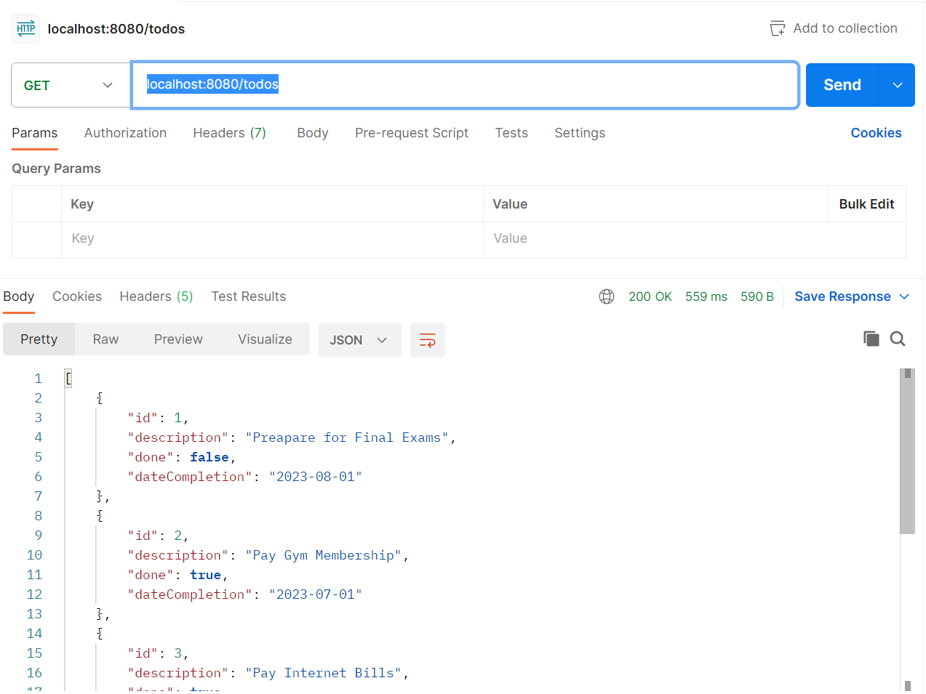

GET todos/{id}

Id = 2

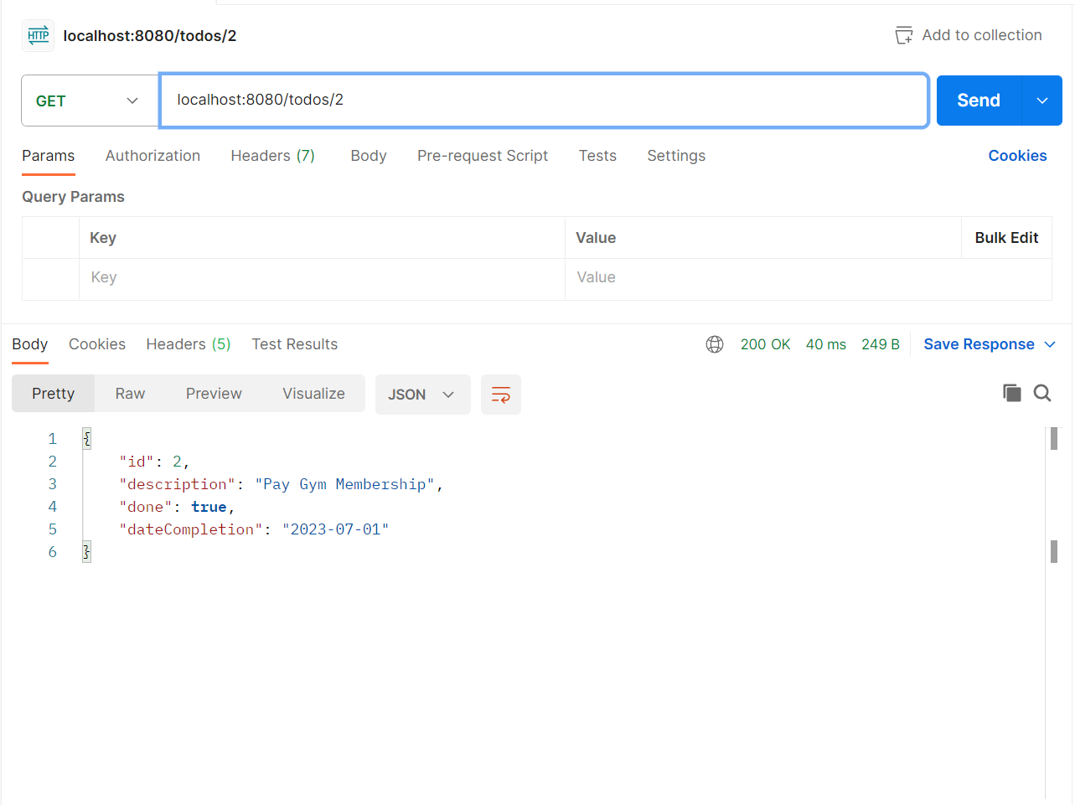

When ID is missing:

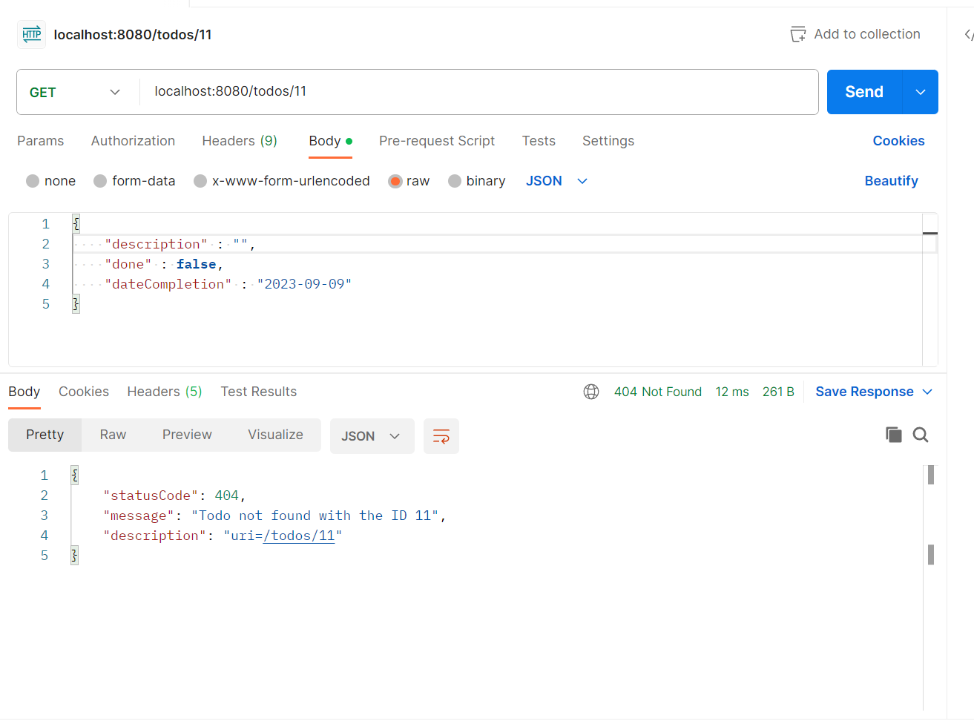

DELETE todos/{id}

Id = 2

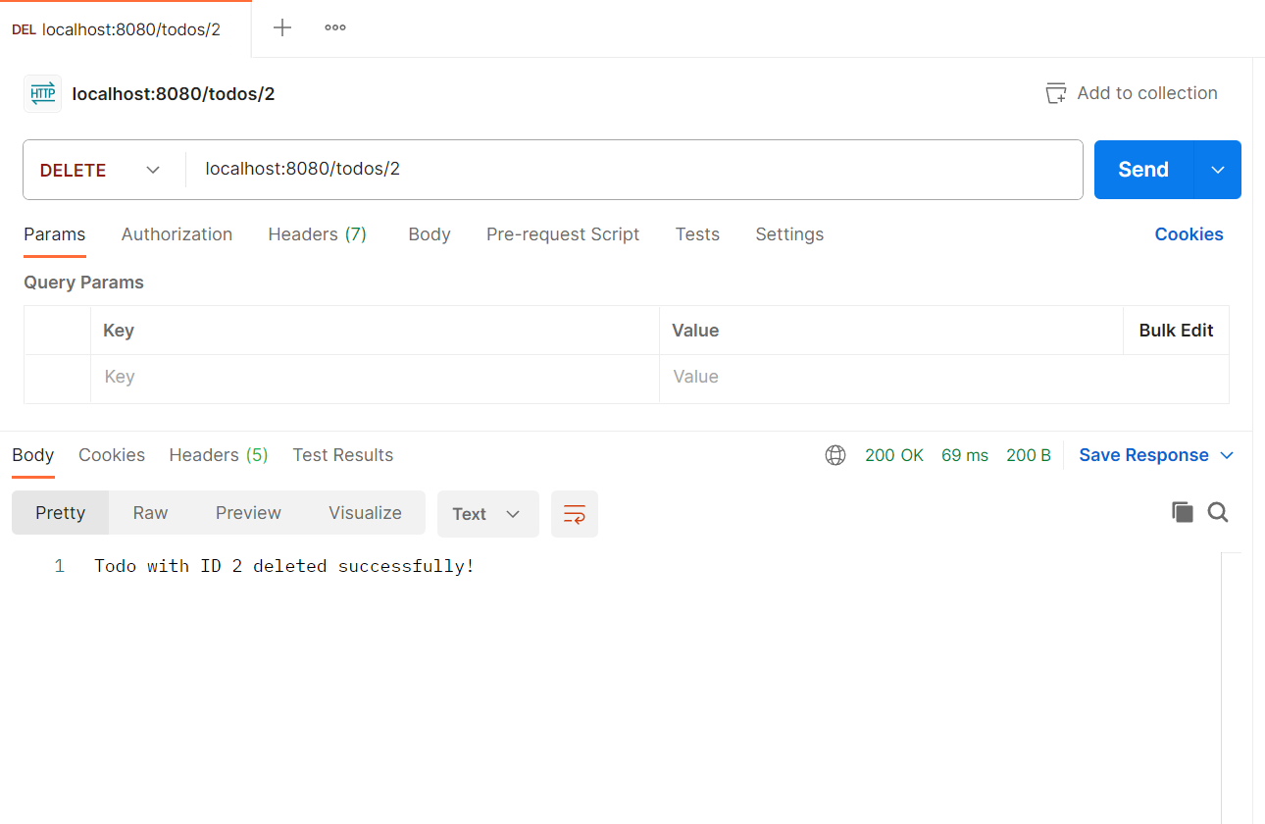

POST /todos

